

 Blockchain in Supply Chains – Use Case Analysis

**Objective/Aim:**  
  
 To analyze how blockchain enhances transparency and traceability in supply chain management.

**Apparatus/Software Used:**

* Laptop
* Remix IDE
* MetaMask
* Vs code

**Theory/Concept:**

1. What is supply chain?  
    A **supply chain** involves multiple parties — manufacturers, suppliers, transporters, warehouses, retailers, and customers — all coordinating to move goods from origin to destination.
2. Traditional supply chains often face problems like:

* Lack of transparency
* Delayed updates
* Fraud and counterfeit products
* Manual errors and inefficiency

1. Implementing blockchain into supplychain:  
   1. IoT sensors can feed real-time data (temperature, humidity, handling conditions) directly to the blockchain.  
   2. Guarantees that goods (like food or medicine) are stored and transported under correct conditions.   
   3. Each product movement or transaction is recorded as a block in the blockchain. Every participant (manufacturer, transporter, retailer, etc.) has a copy of the ledger, ensuring no single point of failure.  
   4. Data is immutable — once recorded, it cannot be changed or deleted, ensuring trust and authenticity.  
   5. Smart contracts automatically execute predefined rules — such as payment release once goods are delivered and verified.



**Procedure:**

The **TraceHerb** project tracks the movement of **herbal products** from farmers to end customers.  
Step 1: Define all stakeholders involved in the supply chain:

**Farmer → Distributor → Retailer → Customer**

Step 2: **Set Up Blockchain Network:**

* Use a blockchain platform (e.g., **Ethereum testnet via Remix IDE and MetaMask**).
* Create a **smart contract** to record transactions such as shipment data, quality status, and ownership changes.
* Each Stackholder has a **unique wallet address** to interact with the blockchain.

Step 3: **Simulate Transactions on the Blockchain:**

* Each participant enters shipment details (e.g., time, location, batch number, and quantity)/ or integrate iot

device to make immutable.

* These details are stored as **blocks** on the blockchain ledger.

Step 4: **Implement Smart Contracts for Automation:**

* Use **smart contracts** to automate actions like:
  + Verifying delivery confirmations.
  + Releasing payments after successful delivery.
  + Recording temperature or quality data (if IoT sensors are integrated).

Step 5: **Verify Data Immutability:**

* Check that once shipment data is recorded, it **cannot be edited or deleted**.
* Demonstrate that blockchain ensures **data integrity and transparency** for all actors.

Step 6: **Track Product Through Ledger:**

* Visualize or query the blockchain ledger to view the **complete journey** of the product.
* Each block shows verified details about who handled the product and when.
* Customers can **trace authenticity** by checking product data on-chain.

Step 7: **Analyze the Results:**

* Confirm that blockchain successfully provides **end-to-end visibility**, **fraud prevention**, and **automated**

**validation**.

* 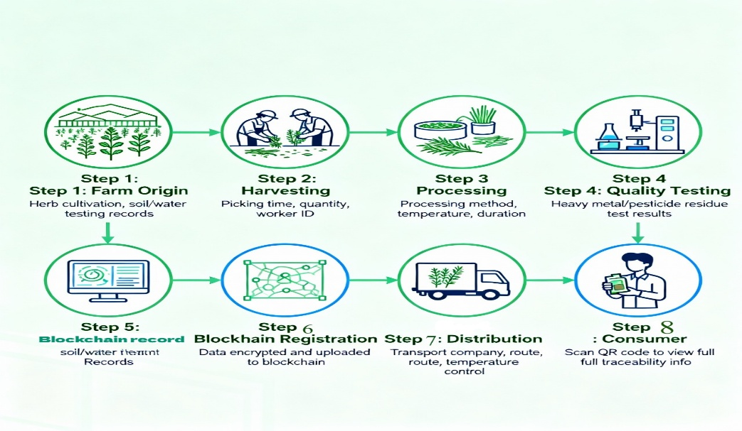Highlight how TraceHerb enhances **trust, quality assurance, and traceability** in the herbal supply chain.

**Observation Table:**



| **Stage** | **Actor** | **Activity / Transaction Recorded** | **Verified by Blockchain Network** | **Data Immutable** |
| --- | --- | --- | --- | --- |
| 1 | **Farmer** | Adds new herb batch with details (origin, quantity, harvest date). | Yes | Yes |
| 2 | **Distributor** | Logs shipment details (batch ID, transport route, dispatch time). | Yes | Yes |
| 3 | **Retailer** | Updates inventory upon receiving shipment and verifies product condition. | Yes | Yes |
| 4 | **Customer** | Scans QR code to verify product authenticity and supply chain history. | Yes | Yes |





|  |  |  |  |
| --- | --- | --- | --- |
|  |  |  |  |
|  |  |  |  |
|  |  |  |  |
|  |  |  |  |
|  |  |  |  |
|  |  |  |  |
|  |  |  |  |